* First, I imported the required libraries and then Imported the data in Python environment.
* Checked the shape of the data. (2224,11) Then checked all the columns in the dataset
* Provided the trend chart for the number of complaints at monthly and daily granularity levels, by converting the date format from Object to Datetime format.
* 
* Visualised daily and monthly requests using line and bar graph.
* Reduced the number of values Status to two from four and used only Open and closed as status for requests.
* 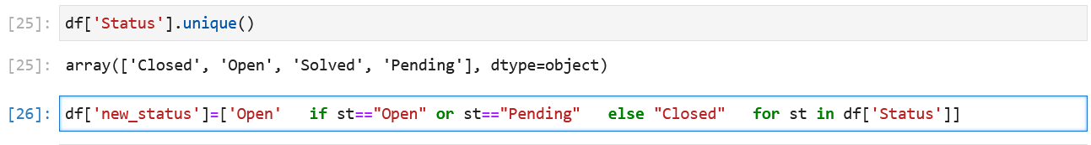
* Used Groupby method and created DF as State_complaint, using column state and Status
* Using state_complaint formed a stacked bar chart, which is showing state-wise closed and open requests.
* Again using groupby found out which state has the maximum complaints and it was State of Gorgia.
* 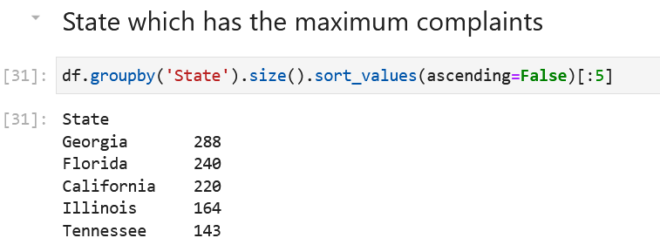
* Then found out which state has highest percentage of unresolved complaints.
* 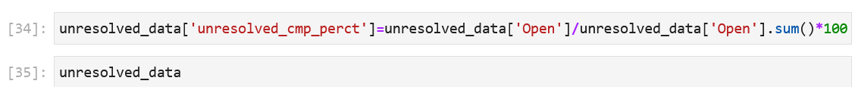
* Provided the percentage of complaints resolved till date.
* 